Data Analysis:

Analysis-1: Box Plot of Writing Scores by Parental Education Level

The box plot visualizes the distribution of writing scores across different parental education levels. The x-axis represents the parental level of education, while the y-axis represents the writing score. Each box in the plot depicts the distribution of writing scores for a particular parental education level. The center line within the box represents the median score, and the box itself encompasses the middle 50% of the data points (interquartile range). The whiskers extend from the box to capture the remaining data points, unless outliers are present, which are then plotted as individual points beyond the whiskers.By analyzing the positions and sizes of the boxes, we can compare the distributions of writing scores across different parental education levels. A box that is higher on the y-axis indicates that students with that particular parental education level tend to have higher median writing scores. The width of the box reflects the variability in writing scores within that group. A wider box suggests a greater spread of scores, indicating more variation in writing achievement.

Analysis-2: Count Plot

The provided visualization is a count plot that depicts the distribution of students across different test preparation course options. The x-axis labeled "Test Preparation Course" categorizes students based on their enrollment in a course (completed or none). The y-axis labeled "Count of Students" indicates the number of students who fall into each category. The pastel color scheme is used for visual distinction between the course completion groups, although the legend is disabled here. By examining the heights of the bars, we can quickly identify the most popular test preparation course option among the students in this dataset. For instance, a taller bar for "none" would suggest that about 620 students not completed the test preparation compared to the about 350 students are completed the course.

Analysis-3: Facet Grid of Race/Ethnicity by Parental Education Level and Gender

This facet grid visualizes the distribution of students across different parental education levels, categorized by race/ethnicity and gender. Each subplot within the grid represents a specific combination of race/ethnicity and gender. The x-axis labeled "Parental Level of Education" categorizes students based on their parents' education attainment. The y-axis labeled "Count of Students" indicates the number of students who fall into each parental education level within that particular race/ethnicity and gender group. The color palette is set to "pastel" for visual distinction between the subplots. By examining the heights of the bars within each subplot, we can identify trends in parental education levels across different racial/ethnic and gender groups. For instance, a consistently taller bar for "Bachelor's Degree" across subplots for a particular race/ethnicity might suggest that a higher proportion of students in that group have parents with a Bachelor's degree compared to other education levels. This facet grid allows for a more nuanced understanding of how parental education, race/ethnicity, and gender intersect in terms of student distribution.

Analysis-4: Histogram of Scores

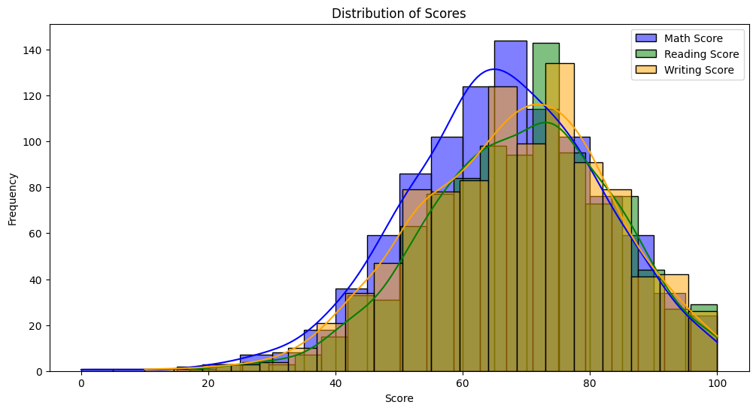

The visualization displays three histograms overlaid on one plot, depicting the distributions of math, reading, and writing scores. The x-axis labeled "Score" represents the range of possible scores, while the y-axis labeled "Frequency" indicates the number of students who achieved each score range. Each colored distribution curve represents a specific test: blue for math scores, green for reading scores, and orange for writing scores. The smooth lines superimposed on the bars depict the kernel density estimation (KDE) of the data, providing a clearer picture of the underlying distribution. By observing the shapes and positions of these distributions, we can compare the score patterns across the three subjects. A distribution that peaks at a higher score on the x-axis suggests that students generally performed better on that subject. The KDE curves can further reveal if the scores are spread out evenly or concentrated around specific values.

Analysis-5: Pair Plot of Scores by Gender

This pair plot visualizes the relationships between math, reading, writing scores, and gender in your data set. Each square in the grid represents a scatter plot for one pair of variables, colored by gender (hue). The diagonal plots (diag_kind='kde') showcase the distribution of each individual score using kernel density estimation (KDE). By analyzing all the plots together, we can gain valuable insights. The upper left corner depicts the relationship between math and reading scores, potentially revealing a positive correlation if students with higher math scores also tend to have higher reading scores. The color gradient within these scatter plots highlights potential gender differences in this correlation. If a particular color cluster leans towards a specific corner, it might suggest a stronger or weaker correlation for that gender in that subject pairing. Similarly, the plots along the bottom row can expose relationships between writing scores and other factors like math or reading abilities, while again colored by gender to uncover any gender-based disparities.

Analysis-6: Pie Chart of Parental Level of Education

The pie chart depicts the distribution of students based on their parents' level of education. Each slice of the pie represents a specific educational attainment level (parental level of education), and the arc lengths correspond to the proportion of students in that category. The colors are chosen from a pastel color palette to differentiate the slices visually. The labels around the pie chart show the specific educational levels (e.g., "High School", "Bachelor's Degree"), and the corresponding percentages indicate the proportion of students in each category. For instance, a large slice labeled "Bachelor's Degree" with a high percentage value (e.g., 35.1%) would signify that a significant portion of students have parents with a Bachelor's degree. This pie chart provides a quick and clear summary of the student population regarding their parents' educational background.

Analysis-7: Scatter Plot of Math vs. Reading Scores

This scatter plot visualizes the relationship between math scores (x-axis) and reading scores (y-axis) for students in the data set. The color of each data point represents the student's gender, differentiated by a pastel color scheme. By examining the distribution of the points, we can explore potential correlations between math and reading abilities. If the data points exhibit a positive correlation, it would suggest that students with higher math scores tend to also have higher reading scores. Conversely, a negative correlation would indicate that stronger math performance is associated with weaker reading scores. Additionally, the plot can reveal gender differences in the relationship between these scores. If a particular color cluster leans towards a specific corner of the plot, it might suggest a stronger or weaker correlation for that gender. The plot also reveals no significant gender differences in this relationship, suggesting that both male and female students exhibit a similar correlation between math and reading scores.

**The graphs that have simplified the analysis for me are:**

Box Plot of Writing Scores by Parental Education Level The box plot effectively shows the distribution of writing scores based on the parental level of education, highlighting the central tendencies (median) and spread (interquartile range) for each education group. It also identifies outliers, revealing students whose writing scores deviate from the majority. This type of visualization makes it easier to spot performance disparities between students from different parental education backgrounds. For instance, students whose parents have higher education levels may tend to score higher, indicating a potential correlation between parental education and student performance in writing.

Scatter Plot of Math vs. Reading Scores The scatter plot provides a clear view of the relationship between math and reading scores, illustrating whether a positive correlation exists between the two. If the points cluster tightly along an upward-sloping line, it suggests that students who excel in math also perform well in reading. This plot is beneficial for spotting trends, correlations, and outliers—students who might excel in one subject while struggling in another. It simplifies the process of identifying linear relationships between subjects and helps pinpoint exceptional cases for further analysis.